• Log-in

• “Manager”

Homepage

Notifications

• Performance Review Projections

These show the interaction of a button to a new screen:

These are screens you would get when you press the button “Link”, “Done”, and “Pending” respectively:

Updated PR Projection Screen:

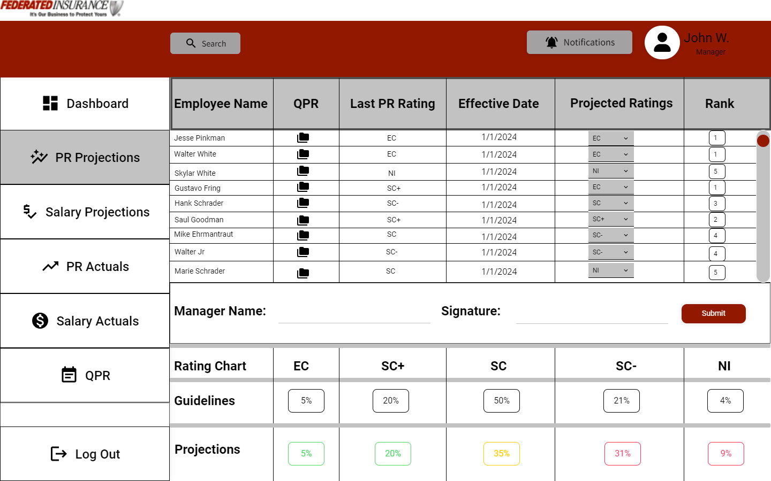

• Salary Review Projections

• Include notification/approval/reporting

Updated Salary Projection Screen:

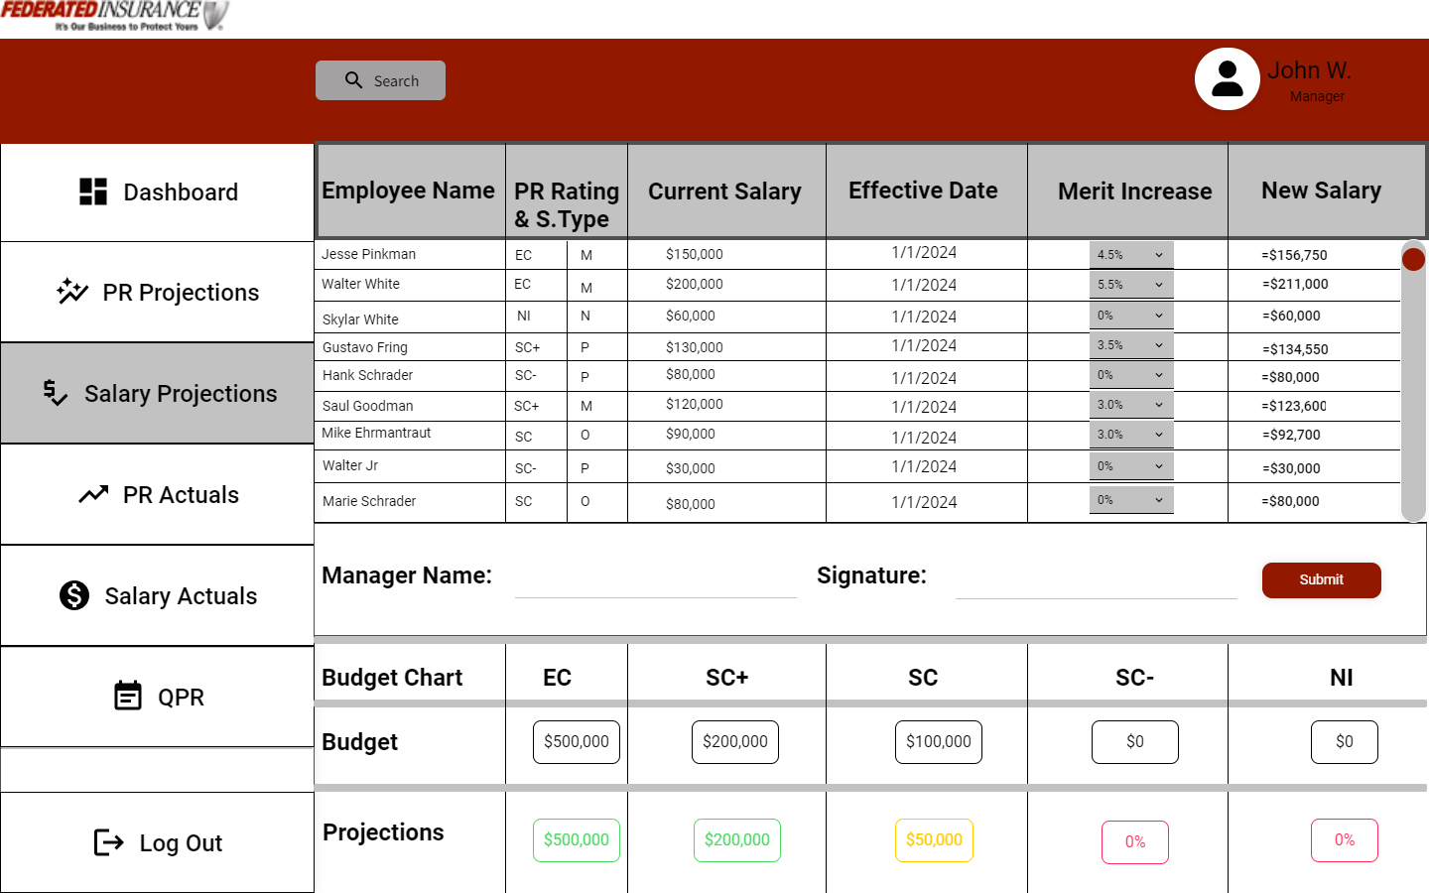

• Performance Review Actuals

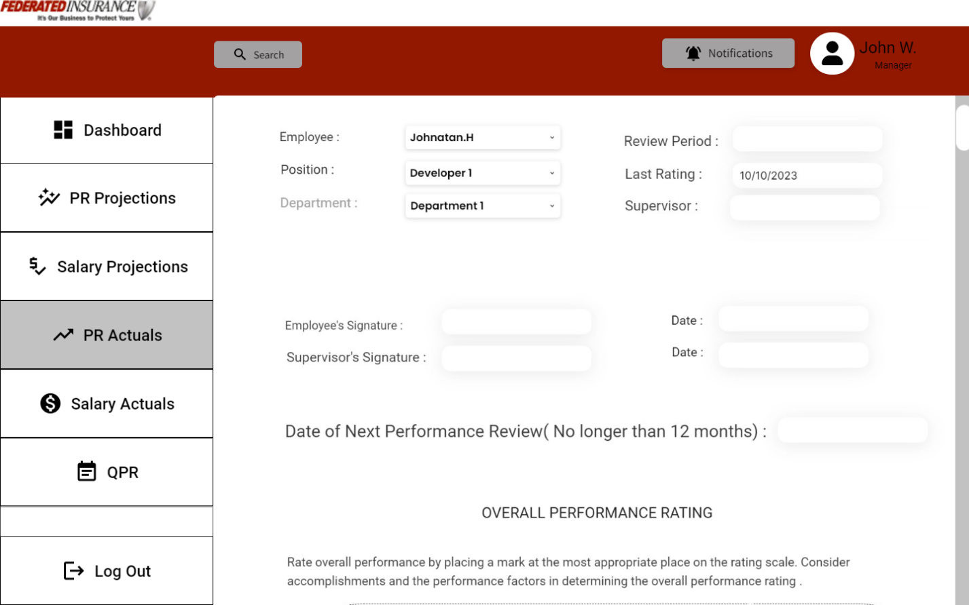

• Salary Review Actuals

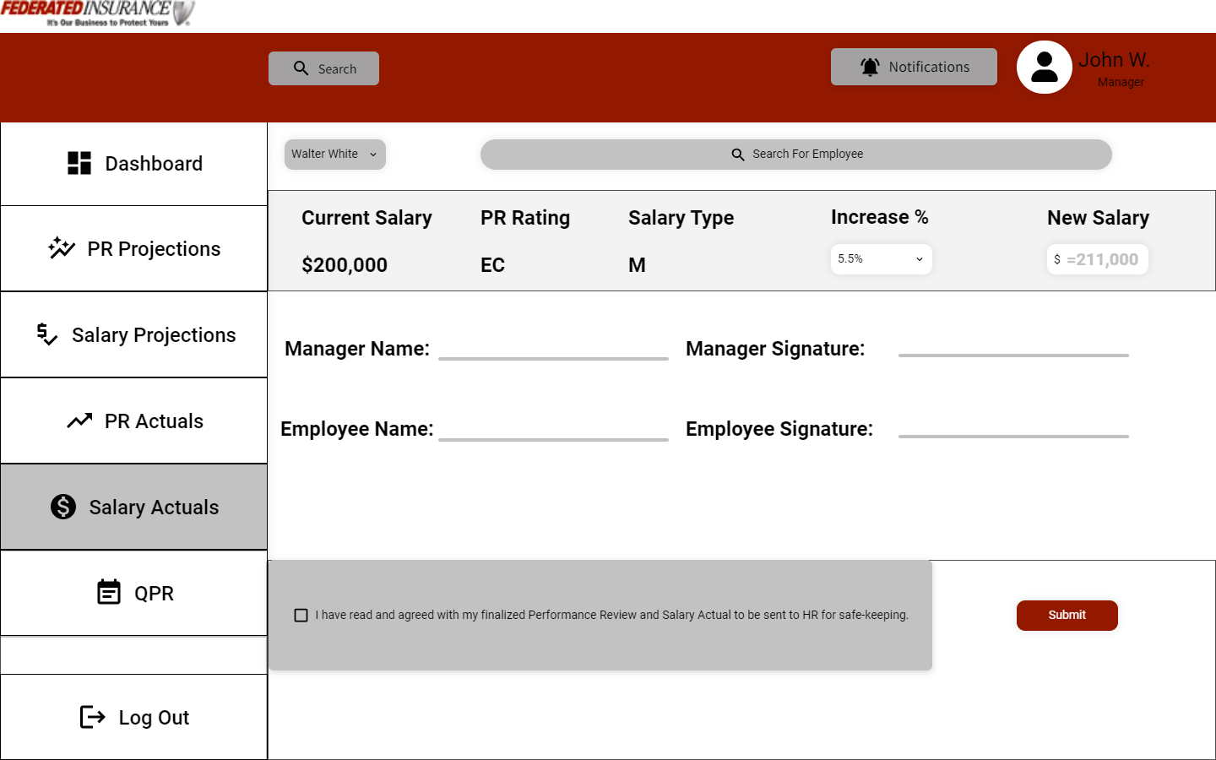

• Quarterly Performance Review

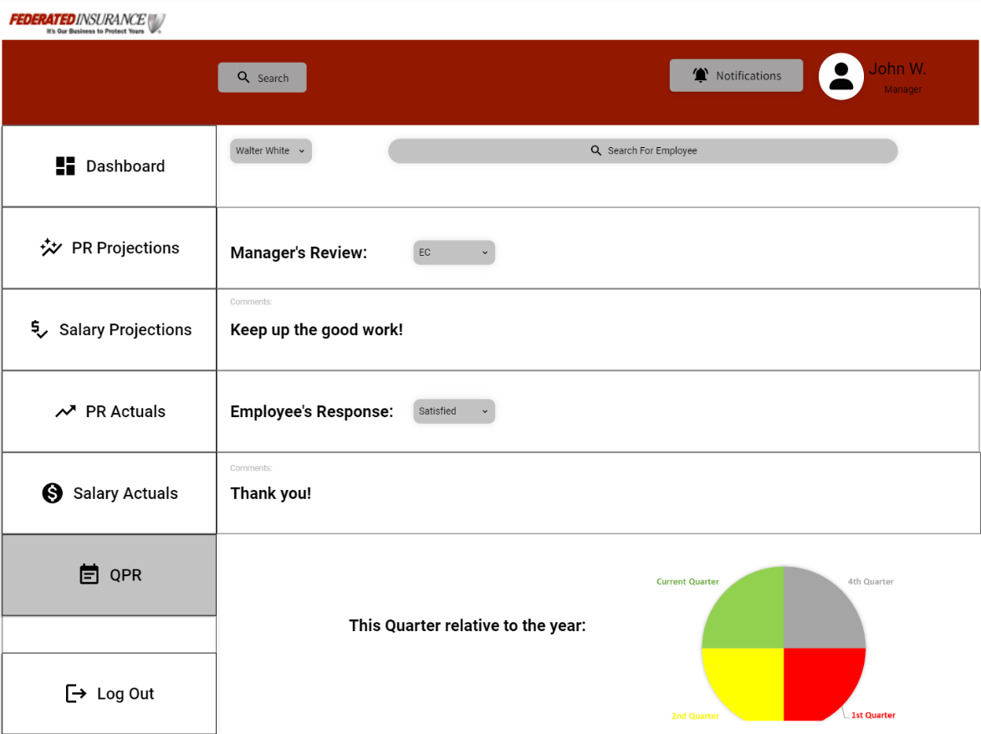

• Staff

• View Salary and Performance Review (including QPR)